Mask Wear Detection using Deep Learning and Computer Vision

Revision Number: 2.0

Last date of revision: 1-09-2021

## Contents

1. Introduction 5
   1. Why this High-Level Design Document? 5
   2. Scope. 5
   3. Definitions 5
2. General Description. 6
   1. Product Perspective 6
   2. Problem statement 6
   3. PROPOSED SOLUTION 6
   4. FURTHER IMPROVEMENTS 6
   5. Technical Requirements. 6
   6. Data Requirements 7
   7. Tools used. 8
   8. Constraints 9
   9. Assumptions. 9
3. Design Details 10
   1. Process Flow. 10
      1. Model Training and Evaluation 10
      2. Deployment Process 11
   2. Error Handling 11
   3. Performance. 12
   4. Reusability. 12
   5. Application Compatibility 12
   6. Resource Utilization 12
   7. Deployment. 12
4. Conclusion 14

Abstract

The new Coronavirus illness (COVID-19) has seriously affected the globe. By the end

of Nov 2020, the worldwide variety of recent coronavirus cases had already exceeded sixty million and the variety of deaths one,410,378 in keeping with info from the globe Health Organization (WHO). To limit the unfold of the illness, necessary face-mask rules area unit currently turning into common in public settings round the world. to boot, several public service suppliers need customers to wear face-masks in accordance with predefined rules (e.g., covering each mouth and nose) once using public services. These developments impressed analysis into automatic (computer-vision-based) techniques for face-mask detection that may facilitate monitor public behavior and contribute towards constraining the COVID-19 pandemic. though existing analysis during this space resulted in economical techniques for face-mask detection, these typically operate beneath the idea that trendy face detectors offer excellent detection performance (even for covert faces) which the most goal of the techniques is to observe the presence of face-masks solely.

1. **Introduction**

###### Why this High-Level Design Document?

The purpose of this High-Level Design (HLD) Document is to add the necessary detail to the current project description to represent a suitable model for coding. This document is also intended to help detect contradictions prior to coding, and can be used as a reference manual for how the modules interact at a high level.

The HLD will:

* + - Present all of the design aspects and define them in detail
    - Describe the user interface being implemented
    - Describe the hardware and software interfaces
    - Describe the performance requirements
    - Include design features and the architecture of the project
    - List and describe the non-functional attributes like: o Security
      * Reliability
      * Maintainability
      * Portability
      * Reusability
      * Application compatibility
      * Resource utilization
      * Serviceability

##### Scope

The HLD documentation presents the structure of the system, such as the database architecture, application architecture (layers), application flow (Navigation), and technology architecture. The HLD uses non-technical to mildly-technical terms which should be understandable to the administrators of the system.

* 1. **Definitions**



*Term MWD*

*Database*

*IDE AWS*

*Description*

Mask Wear Detection

Collection of all the information monitored by this system

Integrated Development Environment

Amazon Web Services

### General Description

#### Product Perspective

The Mask wear detection solution system is a deep learning-based detection as well classification problem model which will help us to detect the anomalies in the society and take the necessary action.

* 1. Problem statement

COVID-19 pandemic has rapidly affected our day-to-day life disrupting the world trade

and movements. Wearing a protective face mask has become a new normal. In the near

future, many public service providers will ask the customers to wear masks correctly to

avail of their services. Therefore, face mask detection has become a crucial task to help

global society.

COVID-19 mask detector could potentially be used to help ensure your safety and the

safety of others.

* 1. PROPOSED SOLUTION

The solution proposed here is a Mask Wear Detection can be implemented to perform use cases and to prevent the covid. if MWD detects Person wear mask or not. If wear person the mask, then he is entering the office gate other wise person didn’t wear the mask then he or she is not entering the office

* 1. FURTHER IMPROVEMENTS

UGV can be added with more use cases like social distancing alert. It can be implemented in the public places like shopping mall, Medical Care Center, Airports, Railways Stations and many more places

#### Technical Requirements

This document addresses the requirements for detecting mask wear

* + - Your system required minimum i5, 8gb ram and 64bit configuration.
    - You have installed python more than 3.6 version of python and TensorFlow version is 2.1.0 and install all requirement libraries like NumPy, Pandas, OpenCV, Keras, Mat plot for reading and analysis the data.

#### Data Requirements

Data requirement completely depend on our problem statement.

* + - We need images data that is balanced and must have at least 1000 images.
    - We require at least 30- 40 images for each class label with annotation.
    - An image is nothing more than a two-dimensional array of numbers(pixels)
    - Pixel value ranging between 0 to 255
    - It is defined by the mathematical function (x, y), the value off (x, y) at any point is giving the pixel value at that point of an image
    - Original image is in the format of (width, height, no of RGB channels).

There are numerous image file formats out there so it can be hard to know which file type best suits your image needs (on your requirement).

a TIFF — Tagged image file format o BMP — Bitmap image file form

a JPEG - Joint photographic experts’ groups o GIF - graphics interchange format

a PNG — portable network graphics a EPS — encapsulated post script a RAW image files

* + - Tiffs are great for printing. These are lossless image files meaning they don’t need to compress or lose any image quality or information. These format images are high quality images.
    - bmp format developed by Microsoft for windows. There is no compression or information loss; this format is generally recommended for high quality scans.
    - JPEG is a lossy format meaning that the image is compressed to make a smaller file but this loss is not noticeable.
    - JPEG is a very popular format for digital cameras.
    - GIFs are widely used for web graphics because they are limited to only 256 colors, can allow for transparency and can be animated. These types of files are typically small in size and very portable.
    - PNG are a lossless image format; these files are able to handle up to 16 million colors unlike the 256 colors supported by GIF.
    - EPS is a common vector type file.
    - RAW images that are unprocessed that have been created by a camera or scanner. Digital cameras can shoot in raw, mostly used in photography.

If the data is in video format like (MP4) convert into images based on FPS (no. of frames displayed per second) in real time processing. There are number of tools to convert videos into images. Using cv we can convert video into images

* 1. Tools used

Python programming language and frameworks such as NumPy, Pandas, Scikit-learn, TensorFlow, Keras are used to build the whole model.







* + - Jupyter is used as IDE.
    - For visualization of the plots, Matplotlib, Seaborn and Plotly are used.
    - OpenCV is used for deployment of the model.
    - TensorFlow and Keras is used for training the data.
    - Python Django is used for backend development.
    - GitHub is used as version control system.

#### Constraints

The Mask Wear Detection solution system must be user friendly, as automated as possible and users should not be required to know any of the workings.

#### Assumptions

The main objective of the project is to implement the use cases as previously mentioned (2.2 Problem Statement) for new dataset that comes through MWD which has camera installed for capturing the live videos. Deep Learning based detection model and classification is used for detecting the above-mentioned use cases based on the input data. It is also assumed that all aspects of this project have the ability to work together in they the designer is expecting.

## Design Details

##### Process Flow

For identifying the different types of anomalies, we will use a deep learning base model. Below is the process flow diagram is as shown below.

##### Proposed methodology

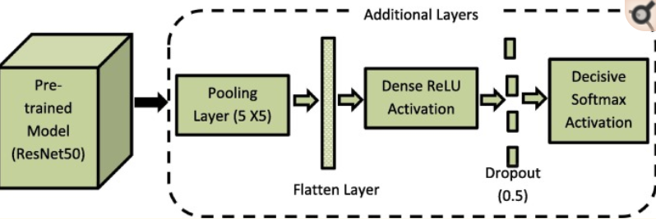

##### Model Training and Evaluation

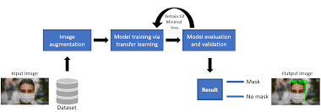

##### Deployment Process

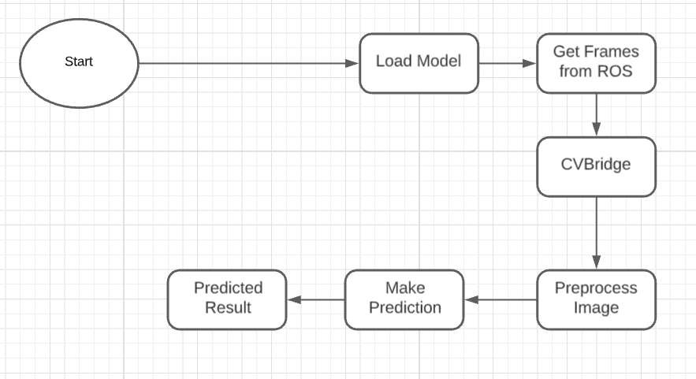

* 1. **Error Handling**

Should errors be encountered, an explanation will be displayed as to what went wrong? An error will be defined as anything that falls outside the normal and intended usage.

1. Performance

The Mask Wear Detection solution is used for detection of mask wearing detection in the society whenever MWD detects any who didn’t wear the mask Also, model retraining is very important to improve the performance.

#### Reusability

The code written and the components used should have the ability to be reused with no problems.

#### Application Compatibility

The different components for this project will be using Python as an interface between them. Each component will have its own task to perform, and it is the job of the Python to ensure proper transfer of information.

#### Resource Utilization

When any task is performed, it will likely use all the processing power available until that function is finished.

* 1. **Deployment**



## Conclusion

The Mask wear detection will detect an anomaly wearing mask data used to train our algorithm, so we can identify the mask wear person in public places, so we can have a pleasant environment in that area or location.